**Spring Data MongoDB Task**

**Start url**

[**http://localhost:8090/employees/new**](http://localhost:8090/employees/new)

**All End Points**

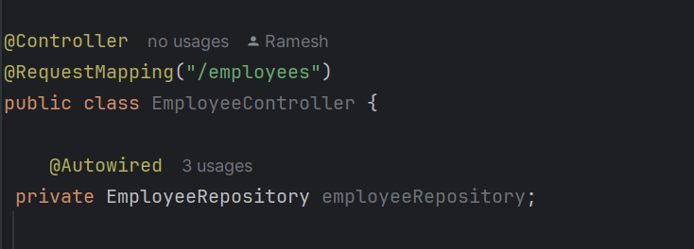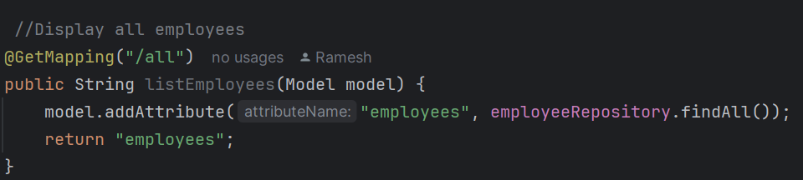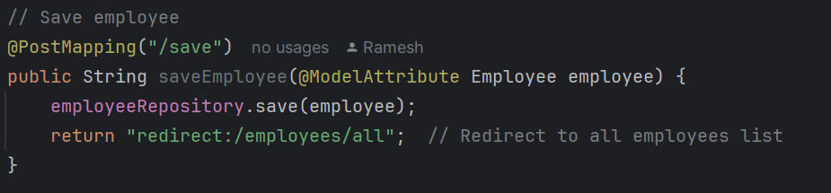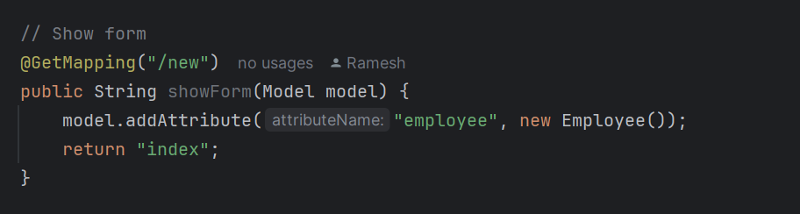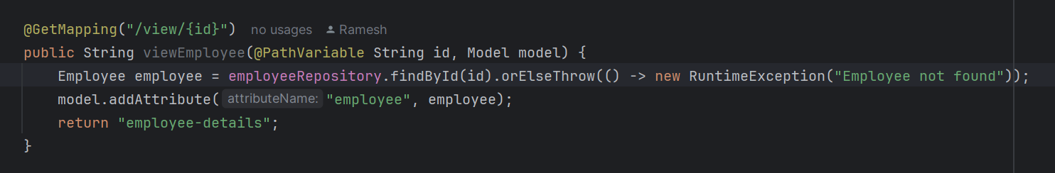

**OUTPUT SCREENS**

**1.screen**

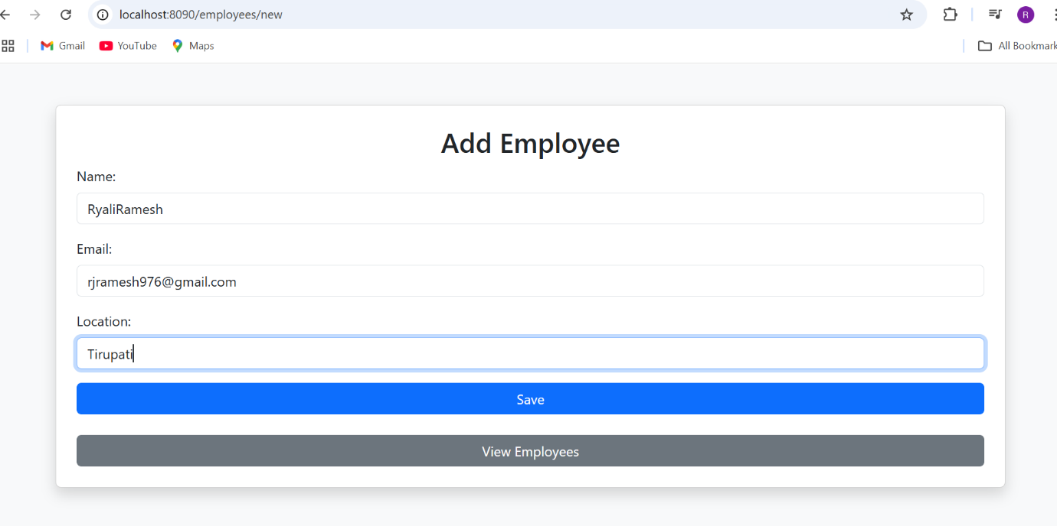

**2.screen**

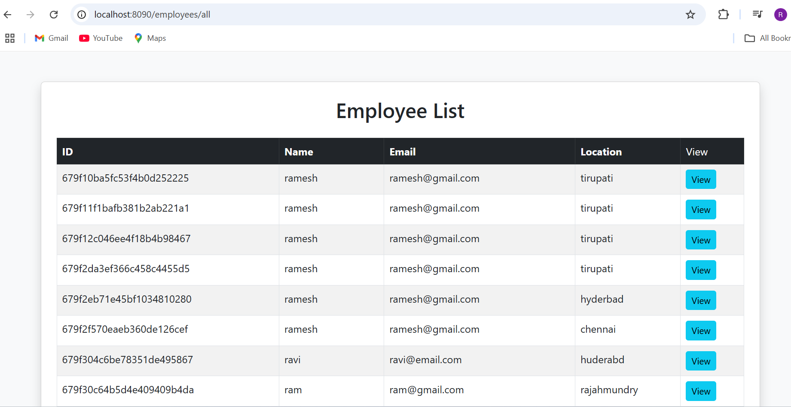

**3.screen**

